Cycling Henry Cowell State Park
This seven-mile loop through the redwoods is an easy novice ride with some short, steep challenges. Trail conditions vary from pavement to sand, so expect to walk some brief stretches.
This park encompasses a variety of climate zones. Redwoods line the streams at the lower elevations, while the ridge tops rise to sun-loving chaparral. Between these zones is a mixed evergreen forest of live oak, madrone, Douglas fir, and ponderosa pine. Usually found above 3,000', the ponderosa pine is a rare species at this elevation, but you'll see an impressive stand around the observation deck.
The wildlife is as diverse as the plant life and you may see a squirrel, raccoon, Eastern fox, coyote, bobcat, or deer. Common birds here include Steller's jays, scrub jays, robins, juncos, chickadees, towhees, acorn woodpeckers, quail, and thrashers. Down near the streams, watch for mallards, blue herons, and kingfishers.
For thousands of years, redwoods dominated this area. The Ohlone Indians inhabited this environment until white settlers came west in droves seeking gold during the mid-1800s. Henry Cowell and his brother were among these"Forty-Niners," but instead of mining gold, they established a profitable drayage business. By the 1860s, Henry Cowell owned much of present-day Santa Cruz. In 1953, his last remaining heir deeded what is now Henry Cowell State Park to the state. To learn more about the Cowell family and the park, stop in at the nature center located at the trailhead. It has a good bookstore and is staffed by very helpful docents.
Finding the trail: From CA 17 in Scotts Valley, take Mount Hermon Road 3 miles west to Graham Hill Road. Turn right and continue a half mile to CA 9 in the town of Felton. Turn left onto CA 9 and travel south 1 mile to the day-use entrance of Henry Cowell State Park.
From Santa Cruz, take CA 9 north for 5 miles and turn right into the park. Follow the main road to the concession area and parking lot. There's a $3 day-use fee per car.
Notes on the trail: After visiting the nature center, continue onto Pipeline Road for 2.2 miles to the Powder Mill Trail. Follow the Powder Mill Trail, staying left at all intersections, up to the Ridge Trail. Your ride crests at the observation deck on the summit. Continue down the other side of the hill, using caution through the sandy sections. Cross over Pipeline Road at the intersection and follow the Rincon Trail out to the Cathedral Redwoods Trail. Return to the parking area on Pipeline Road.
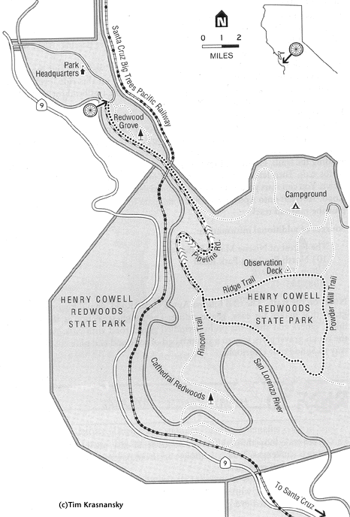
Henry Cowell State Park
Trail Map
Length/configuration: 7-mile loop.
Aerobic difficulty: Easy, with some short, steep challenges.
Technical difficulty: Easy, except for a few sandy stretches.
General Location: On CA 9, 5 miles north of Santa Cruz.
Elevation Change: The elevation of the parking area is close to 200'. The trail climbs to the observation deck at 800' for a total gain of 600'.
Season: Fall through late spring is the best time to ride here because the weather is cool and usually dry enough, and the park is much less crowded. The summer months bring many more visitors to the park and the trails can get very busy. If you plan to ride during the summer, avoid weekends and holidays, or get out on the trails early to avoid the crowds.
Services: The concession area at the trailhead sells food and also has water and rest rooms. Just north of the park, the little town of Felton has a grocery store and several restaurants. The coastal resort of Santa Cruz, just south on CA 9, offers numerous stores, restaurants, and hotels.
Hazards: On the far side of the observation deck, the whole trail consists of soft sand with a series of water bars to divert water off the trail. These water bars alternate with drop-offs that can make riding this section very tricky. Do not try to ride around them because you'll promote trail erosion and defeat the purpose of the water bars. You might prefer to walk your bike through this section, especially if you're new to mountain biking.
Rescue Index: You are never farther than 3 miles from the trailhead and help is available at either the nature center or the concession area.
Land Status: California state park.
Maps: A map is available for $0.50 at park headquarters.

